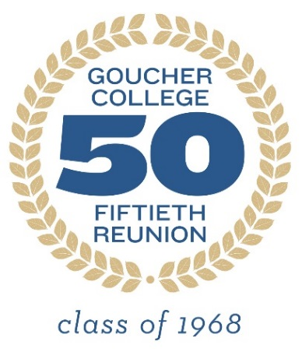
Dear Classmate,

Our Reunion Committee would like to gather some information about each of us individually and about all of us as a group. The questionnaire is completely voluntary. If there is any question you choose not to answer, just leave it blank. The questionnaire is long, but it should give us invaluable information about ourselves collectively. You may wish to read through the whole questionnaire first, think about it, and then answer it.

The first part of the questionnaire contains general information that will be shared with the reunion class, unless you say that you do not wish to share it. We shall compile this information into a booklet so that each of us will have some information to update ourselves on our colleagues as we get together. We plan to include our yearbook picture as well as a current photo for each of us to help recognize each other as we come together, so please send the Alumnae/i Office a current picture of yourself.

The second part of the questionnaire will provide information about our class as a group. This will help us and Goucher to understand what in our college education was most useful from the perspective of many years. It also contains information about what we have done for the last 50 years. This information will only be analyzed in aggregate form. None of the results presented will enable anyone to identify an individual.

The third part relates to our futures. While most reunion questionnaires focus on the past, as women in our early 70's, statistics tell us that we have a good 15 to 20 years ahead of us, maybe more. What do we hope to do with this valuable time? What do we think about it? In some ways, this may be the most exciting part of the questionnaire. Your answers to this section will also be confidential and analyzed only in aggregate form, although we hope it inspires you to have interesting conversations at reunion.

The data will be analyzed by Dr. Grace Clark, a member of our class. She has recently retired from a position as Dean and Chair of the Sociology Department at a university in Pakistan, so she has experience with questionnaires and their analysis. If possible, Grace would like to put together an academic article about what a college education means to women of our generation as well as how we think about the future. If you have any questions about the questionnaire, you are welcome to call or text her at 410-456-9675 or email her at forsting@aol.com. Of course, you may also wish to call the Goucher Alumnae/i Office (410-337-6077).

Your answers are important to learning more about what we have done as a class and hope to do in the future. Please take the time to answer the questionnaire and return it electronically or by mail to the Alumnae/i Office by March 30, 2018 or sooner if you can. Thank you for your participation.

Grace Clark ‘68 | Jinny Muse Fleischman ‘68

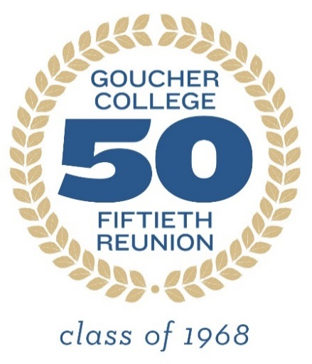
Goucher College Reunion Questionnaire
Part I. General Information
This section will be shared with classmates. If there is an answer you do not want shared, please note that answer by putting the response in italics. As with all the questions, your response is voluntary. If there is any question you do not wish to answer, just skip it.

1. Your name now: ______________________________ At Goucher: __________________________

2. Best mailing address: _______________________________________________________________
___________________________________________________________________________________

3. Cell phone: _________________________Other phone: ___________________________________

4. Best email: _______________________________________________________________________

5. Which of the following apps do you use? __ Facebook ___ Twitter
__Linked in __Instagram __What's App Other (specify) __________________________________

6. What was your major at Goucher? ____________________________________________________

7. Is there a particular memory from your major you would like to share?___________________________________________________________________________________________________________________________________________________________________________________________________________________________________________________

8. Is there a memory you would like to share about a class outside your major?___________________________________________________________________________________________________________________________________________________________________________________________________________________________________________________

9. Did you live on campus? ___Yes __No

10. If yes, in what house(s) did you live? __________________________________________________
11. Is there a particular social/sports/extracurricular memory you would like to share? ______________________________________________________________________________________________________________________________________________________________________

12. After Goucher, did you earn a Masters' degree? ___Yes __No
If yes, in what subject? _____________________________ In what year? _______________________
From which university? _______________________________________________________________

13. Did you complete another professional or advanced degree? ___ M.D. __J.D. ___PhD.
(subject) ____________________________ other (specify) __________________________________
If yes, from what university? _________________________________ In what year? ______________

14. What do you consider the most important or interesting jobs you have held?
1._________________________________________________________________________________2._________________________________________________________________________________3._________________________________________________________________________________

15. Was most of your career in the subject you majored in at Goucher? __Yes ___No

16. If your career wasn't in your major, what did you learn from your major that you used in your career? ____________________________________________________________________________

17. Are you currently employed? ___Yes ___No Doing what? ______________________________

18. Do you consider yourself retired? __Yes ___No ___Semi-retired

19. What is your marital status? __Never married __Married __Divorced __Widowed

20. Spouse(s)
Name From date To (including present)
a._________________________________________________________________________________
b._________________________________________________________________________________

20. Children? Name(s) Age Goucher graduate or student?
a._________________________________________________________________________________
b._________________________________________________________________________________
c._________________________________________________________________________________
d._________________________________________________________________________________
If more than four, please add lines at the end of this section.

21. What are your current volunteer or civic activities that you enjoy? __________________________
___________________________________________________________________________________

22. What do you like to do for fun? ___________________________________________________________________________________
23. What is the most interesting book(s) you have read this year? ______________________________________________________________________________________________________________________________________________________________________

24. What do you remember about the weekend of the assassination of Dr. Martin Luther King? (Our senior Prom weekend)________________________________________________________________
_________________________________________________________________________________________________________________________________________________________________________________________________________________________________________________________

25. What do you remember about the weekend of the assassination of Robert Kennedy? (Graduation Weekend)
_________________________________________________________________________________________________________________________________________________________________________________________________________________________________________________________

26. Is there anything else you would like your classmates to know about you?
_________________________________________________________________________________________________________________________________________________________________________________________________________________________________________________________

Please send a current picture of yourself to the Alumnae/i Office. This will be included in the booklet together with your yearbook photo. Thanks.

Part II. The Goucher Experience and Individual Information
Results from this part of the questionnaire will be analyzed in the aggregate to give us a better picture of class our as a whole. If you choose not to answer a particular question, just skip it and go on to the next. Information from this section will be confidential. No one's individual data will be identifiable.

The Goucher experience

1. Overall, how would you evaluate the education you received at Goucher?
__Excellent __Very good __Good __Fair __Poor
Comments: ______________________________________________________________________________________________________________________________________________________________________

2. How well do you feel Goucher prepared you to continue learning throughout your life?
__Incredibly well __Very well __Pretty well __Fair __Poor
Comments: _________________________________________________________________________

3. How well do you feel Goucher prepared you for advanced degrees?
___Does not apply ____Incredibly well __Very well __Pretty well __Fair __Poor
Comment: __________________________________________________________________________

4. How well do you feel your major courses prepared you for your career?
____Incredibly well __Very well __Pretty well __Fair __Poor
Comment: __________________________________________________________________________

5. How well do you feel your non-major courses prepared you for your career?
____Incredibly well __Very well __Pretty well __Fair __Poor
Comment: __________________________________________________________________________

6. Was there anything about your Goucher experience you found negative? ___Yes ___No
Please explain_______________________________________________________________________
___________________________________________________________________________________

7. What was the most important thing you learned from your major?___________________________________________________________________________________________________________________________________________________________________________________________________________________________________________________

8. Was there anything in your major that you found limiting?__________________________________________________________________________________________________________________________________________________________________________________________________________________________________________________

9. What language(s) did you study at Goucher? Please check all that apply.
__French __German ___Spanish __Russian ___Latin ___Greek
How many years? ____________________________________________________________________

10. Would you have liked to have learned a foreign language better? __Yes __No

11. How helpful was Goucher in explaining graduate school options?
__Extremely helpful __Very helpful __Somewhat helpful __Slightly helpful __Not at all helpful
Comment: __________________________________________________________________________

12. How helpful was Goucher at helping you to find a job?
__Extremely __Very helpful __Somewhat helpful __Slightly helpful __Not at all helpful
Comment: __________________________________________________________________________

13. Have you asked for help from the career office since graduation? ___Yes ___No
What was your experience? ____________________________________________________________

14. Was there anything you would have liked Goucher to include in your education that it did not? Please discuss _______________________________________________________________________ ______________________________________________________________________________________________________________________________________________________________________

15. What are you most proud of Goucher for since we graduated? ______________________________________________________________________________________________________________________________________________________________________

Information about the Individual

1. How would you rate your health at this time?
__Excellent __Very good __Good __Fair __Poor

2. What do you do for exercise? ______________________________________________________________________________________________________________________________________________________________________

3. How much do you exercise each week? __None __0.1 to 3 hours __3.1 to 6 hours
____6.1 or more hours___________________________________________

4. Do you enjoy traveling? __Yes __No

5. Where have you traveled in your life?_____________________________________________________________________________________________________________________________________________________________________________________________________________________________________________________

6. How would you define yourself politically? __Republican __Democrat __Independent

7. Do you consider yourself __Conservative ___Moderate ____Liberal ____ Very liberal
8. How often do you vote?
__Always ___Usually ___Sometimes __Rarely ___Never

9. What do you plan to do in the 2018 election? __Nothing __Vote __Get the vote out
___Give money to candidates I support ___Participate in a political organization
___Provide policy papers __Other (specify) ______________________________________________
___________________________________________________________________________________

10. What do you see as the most important issues facing our country? Up to five
___________________________________________________________________________________
______________________________________________________________________________________________________________________________________________________________________

11. What are the most important issues facing your community?
____________________________________________________________________________________________________________________________________________________________________________________________________________________________________________________________________________________________________________________________________________

12. How involved are you in any of these issues?
__Very active __Active __Participate from time to time ___Rarely participate __Inactive
Comment______________________________________________________________________________________________________________________________________________________________

13. Did you consider yourself part of a religious tradition while at Goucher? ___Yes ___No
If yes, which? _______________________________________________________________________

14. Do you consider yourself a member of a religious tradition now? __yes ___No
If yes, which? _______________________________________________________________________

16. Do you prefer to read fiction or non-fiction? ___Fiction ___Non-fiction __Like both

17. What were the last three books that you read? _________________________________________________________________________________________________________________________________________________________________________________________________________________________________________________________

Part. III The Future

As we reach our 50th anniversary, it is an opportunity to look ahead as well as back. The next section asks questions about your future.

1. Do you plan to work for pay in the next five years? __Yes __No
If yes, doing what? ___________________________________________________________________

2. Do you have plans to retire? ____Yes ___No ___Already retired
3. Do you plan to take part in volunteer activities in the next several years? ___Yes ___No
If yes, which ones and in what capacity?
a._________________________________________________________________________________
b._________________________________________________________________________________c._________________________________________________________________________________

4. What are your most important personal goals for the next five years?
a._________________________________________________________________________________
b._________________________________________________________________________________
c._________________________________________________________________________________

5. What do you worry about most in terms of our country?
____________________________________________________________________________________________________________________________________________________________________________________________________________________________________________________________________________________________________________________________________________

6. What do you worry about most in terms of your community? _________________________________________________________________________________________________________________________________________________________________________________________________________________________________________________________

7. What do you worry about most in terms of your family?
_________________________________________________________________________________________________________________________________________________________________________________________________________________________________________________________

8. What do you worry about most for yourself?
_________________________________________________________________________________________________________________________________________________________________________________________________________________________________________________________

9. If you had time, money, and health, what would you most want to do in the future?
a._________________________________________________________________________________
b._________________________________________________________________________________
c._________________________________________________________________________________

10. What would you like to do with your family that you haven't done before? ______________________________________________________________________________________________________________________________________________________________________

11. Are there any ways that you feel you could help Goucher?
Please specify_______________________________________________________________________
___________________________________________________________________________________

12. Do you think there are any ways that Goucher could help you now?
Please specify _______________________________________________________________________ ______________________________________________________________________________________________________________________________________________________________________

Return by March 30, 2018
Please send a current picture of yourself to the Alumnae/i Office for inclusion in the booklet.

By mail: | By email:
Office of Alumnae/i Affairs  Goucher College  1021 Dulaney Valley Road  Baltimore, MD 21204 | lynn.satterfield@goucher.edu

