Goucher College

Accessibility Services
for Graduate Programs
A FACULTY GUIDE
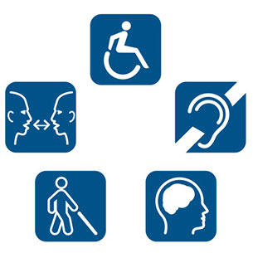
Contents

Accessibility Services Overview 3
Goucher College 3
Graduate Programs 3
Goucher College Accessibility Contacts 4
Primary Goucher College Contact 4
Primary Welch Center Contact 4
Assistive Technology at Goucher College: 4
Accessibility Service Providers 5
Karasch & Associates 5
Deaf Student Instructions for Joining the Remote Cart Captioner For On-Campus Classes 5
Access Portal to Karasch Scheduler for Cart Transcriptions 5
Interpreter Services 5
Zoom Meeting Set-up Instructions for CART & Interpreter Services 6
1: Host Schedules Meetings 6
2: Conduct a One-time Short Test Meeting with CART Services 6
3: Update Zoom Meeting Instructions Page in Canvas Course Site 6
4: Hosting Your Meeting 6
Notes for Your In-Progress Meeting 7
12-Step Accessibility Checklist for Canvas Courses 8
Quality Matters Standards for Accessibility and Usability 8
Faculty & Instructional Designer Outcomes in the Canvas Course Site 8
Universal Design for Learning 9
Responsibilities 10
Working with Students with Disabilities 11
Faculty Reflections & Recommendations 11

Accessibility Services Overview

Goucher College
Goucher College seeks to provide equal educational opportunities for qualified students with disabilities. This is consistent with our Community Principle of Inclusion, which states that we will acknowledge and embrace the unique gifts and differences of our community members. We are committed to compliance with Section 504 of the Rehabilitation Act of 1973, the Americans with Disabilities Act (ADA), and other relevant state and federal legislation.
The Office of Accessibility Services (OAS) works with faculty, staff and students to provide appropriate accommodations so that students have an equal opportunity to participate inside the classroom and in college programs and activities.

Graduate Programs
Much of the information in this document relate to current needs of a deaf student - the focus of work in CSP so far. But it does not outline services/procedures for a student (or faculty, for at matter) who is blind, has a learning difference, has mobility issues, etc. The document will expand to include new knowledge...

Goucher College Accessibility Contacts

Primary Goucher College Contact
Amanda Freeman - Interim Accessibility Services Coordinator
amanda.freeman@goucher.edu - 410-337-6263 - Van Meter G42

Welch Center Contacts
Linda Hill - Director of Distance Learning
linda.hill@goucher.edu - 410-337-6223 - Julia Rogers 214

Brandon Myers – Assistant Director of Digital Learning
brandon.myers@goucher.edu - 410-337-6091 - Julia Rogers 215

Assistive Technology at Goucher College
- The Goucher College Library provides a dedicated Kurzweil 3000 text-to-speech setup for the use of on-site students, faculty, staff and other Library community members. Users can scan printed materials, such as books or other course readings, and the software will read the text aloud to the user.
- Students with a documented disability can also access Kurzweil Firefly available for download to your personal devices through Arnelle Hanley or the Academic Center for Excellence (ACE).
- The College also subscribes to Bookshare, an accessible online library. To gain access to the service, please contact the Academic Center for Excellence (ACE).
- Apple computers have a number of accessibility features built in to the operating system. Visit Apple's page on accessibility) to learn more.

Microsoft's guide to accessible features includes the Windows operating system and Microsoft Office programs.

Accessibility Service Providers

Interpreter Services

Carrie Quigley & Associates
11804 Bristolwood Terrace, Laurel, MD 20708
301-776-2395 - emergency on-call number during an event
Contact: Carrie Quigley - pcquigley@comcast.net
Interpreters: Carl, Karina
Interpreting @ $80/hr – 2 hour minimum

Remote & Onsite CART & Transcription (CART = Communication Access Realtime Translation)
Karasch & Associates
1646 West Chester Pike, Suite 4, West Chester, PA 19382
Contact: Brittany Bobbin - BBobbin@karasch.com - 800-621-5689 – office
484-889-6031 - emergency on-call number during an event
Remote CART @ $100/hr – 1 hour minimum (billed in .50 hourly increments after 1 hour)
On-sites CART @ $200/hr – 2 hour minimum

Deaf Student Instructions for Joining the Remote Cart Captioner For On-Campus Classes
- Click on this link: https://karaschmeetings.webex.com/karaschmeetings/j.php?MTID=m03d0da45e4c879b0ee550aef51b642ee
- Follow the prompts to add WebEx to your Chrome extension (Karasch does not recommend using Internet Explorer or Firefox).
- Plug in the microphone, and in WebEx connect the audio in the Speaker/Microphone menu.
- The captioner will then share their screen, and you will be able to see the captions from there.

Access Portal to Karasch Scheduler for Cart Transcriptions
To access the transcripts, you can go to http://portal.karasch.com/ - or http://portal.karasch.com/users/sign_in and log in. +1-800-621-5689 for problems with the Access Portal/Scheduler.

Zoom Meeting Set-up Instructions for CART & Interpreter Services

1: Host Schedules Meetings
Step 1. Faculty and instructional designer, in conjunction with Amanda Freeman and Linda Hill, determine if the student needs interpreter services and/or remote CART services (with transcription) for each Zoom meeting.
Step 2. Faculty and student needing accessibility work together to select dates and times for the Zoom meetings.
Step 3. Faculty informs instructional designer of confirmed dates/times.
Step 4. 7-10 days in advance of meetings (or sooner), faculty or designer provides Amanda Freeman with all critical details: date, start time, end time, needed services, and Zoom meeting links. CC all parties. Use this format to apprise Amanda:
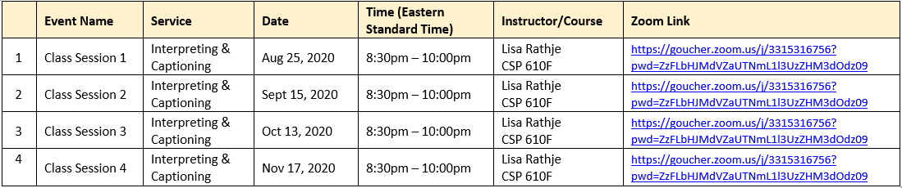

2: Conduct a One-time Short Test Meeting with CART Services
One-time only per term: Before conducting the first Zoom meeting of the term, coordinate with Amanda Freeman to conduct a test meeting to include the CART services company.

3: Update Zoom Meeting Instructions Page in Canvas Course Site
Provide students (and guests when needed) with instructions for joining the meeting/s. Zoom meeting instructions for faculty appear on the Zoom Meeting Instructions page in your course site.

4: Hosting Your Meeting
Step 1. Faculty: Log into your meeting 15 minutes early using instructions for hosting / starting a meeting:
- Go to https://goucher.zoom.us =>
- Click Sign in in the upper right to go to Goucher’s Zoom portal page =>
- Enter username and password and click on Sign in =>
- Hover over HOST A MEETING at the top of your My Profile page and click on With Video On (upper right) =>
- If prompted, click to Join Audio Conference By Computer.
- Alternatively to the Step 1 instructions, start your meeting via the Zoom app.
Step 2. For Remote Cart Services:
- As soon as possible after starting your meeting 15 minutes early, send an email to Brittany Bobbin at Karasch - BBobbin@karasch.com - containing the ingestion link—the “API token” that can only be generated during a live meeting.
- To obtain the ingestion link/”token”: Click on the Closed Caption icon in the Zoom task bar => Underneath “Use a 3rd party CC service,” click on the button Copy the API token => Paste the token into the body of the email message.
- Subject line for the mail message to Bbobbin@karasch.com: Urgent: Ingestion Link/Token for Goucher College Zoom Meeting [insert date]. Note: The API token/ingestion link is different than your Zoom meeting link. The ingestion link allows the captioner to caption -- but it also allows the captions to appear in the active Zoom window so that the deaf student can see the captions. This link can only be generated during an active meeting.
- Click on Chat in the Zoom taskbar to open the Chat window. As soon as the captioner logs into the meeting, copy the ingestion link into the Chat.
- Click on the Close Caption button. This will make the button available to attendees, who will then have the option to view closed captions as they are generated on the lower part of the active Zoom window. The Zoom meeting host (faculty) does not see captions, whereas regular attendees (students) will. Students must click on the CC captions button in order to see the captions.
Step 3. If you want to record your meeting, click the Record button => Click on Record to the Cloud. Click End Meeting when your meeting is finished.

Notes for Your In-Progress Meeting
- For Interpreter Services: Interpreter will join the meeting as an attendee and connect with student individually (one-on-one).
- To turn on and off closed captions in the active Zoom window, click the CC button in the active Zoom meeting. Be sure you are using the latest Zoom app. How to View Closed Captions (for all participants - host as well as student and guest attendees).
- Students can record the Zoom meeting to their own computer but the host needs to give them permission by clicking on More in the Participants window, then selecting Allow Record next to each attendee’s name. See 0:35 (35 second into) this video: https://www.youtube.com/watch?time_continue=44&v=4w_pRMBEALE
- Zoom Technical Support: +1.888.799.9666 ext 2 or +1.650.397.6096 ext 2. You will need to give the meeting ID, which can be found in your Zoom meeting instructions. It is the 10-digit number at the end of your Zoom meeting URL, e.g., 123-456-7899.
- Karasch & Associates Remote CART Technical Support: 484-889-6031
- Interpreter Technical Support: 301-776-2395 Carrie Quigley

12-Step Accessibility Checklist for Canvas Courses

Quality Matters Standards for Accessibility and Usability
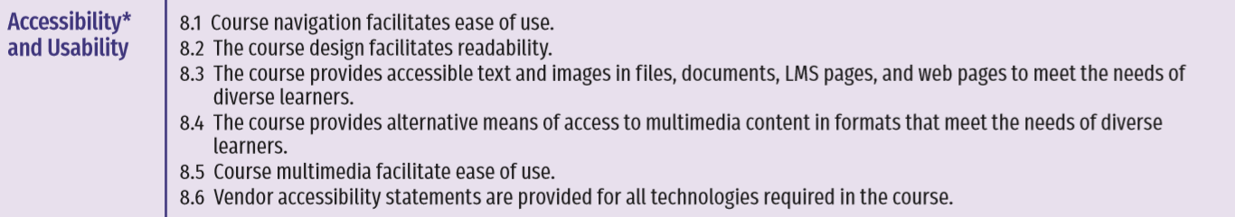

Faculty & Instructional Designer Outcomes in the Canvas Course Site
* Step One | Information on the accessibility of the learning management system and additional required technologies is provided. (8.2)
* Step Two | Links to accessibility statements for all required technologies is provided. (8.2)
* Step Three | Audio and video have transcripts or captioning. (8.3)
* Step Four | Contrast is used to make text easy to read. (8.1)
* Step Five | Images are appropriately sized and can be viewed in their entirety without scrolling. (8.5)
* Step Six | Design format is consistent throughout the course. (8.1)
* Step Seven | Font styles and sizes are consistently used. (8.4)
* Step Eight | Navigation is easy and intuitive. (8.1)
* Step Nine | A text equivalent for images is provided. (8.4)
* Step Ten | Heading styles are used. (8.4)
* Step Eleven | Files have been tested with an accessibility checker. (8.4)
* Step Twelve | Course multimedia are easy to view, operate, and interpret. (8.5)

Universal Design for Learning
- http://udlguidelines.cast.org/
- https://msu.edu/~lopezr11/UDLChecklist.pdf
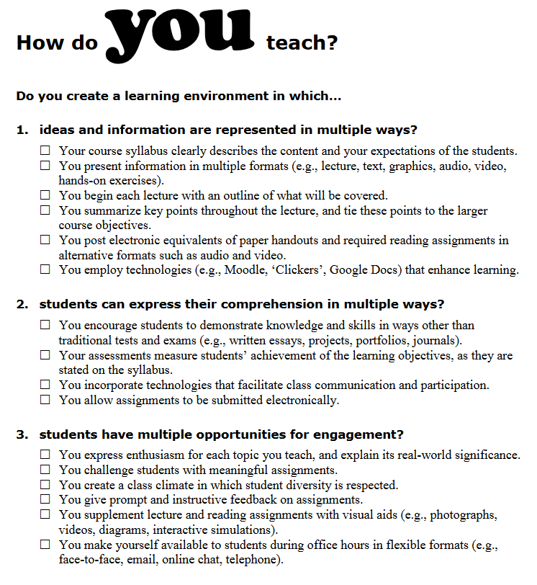

Responsibilities
Goucher College | - Goucher College is responsible for providing access to course content.
Academic program director | - Inform faculty member, instructional designer, Amanda Freeman, Brandon Myers, and Linda Hill about general accommodation needs 2-3 months in advance of a new term
Distance learning staff | - Connect with faculty members to determine instructional needs related to accessibility  - Work with faculty on implementing Universal Design for Learning and accessibility provisions in courses  - Keep all parties informed about developments  - Coordinate Zoom technical test to include instructor and distance learning staff
Instructor | - Meet ongoing with instructional designer  - Include references to accessibility in course syllabus (syllabus will be provided to service providers)  - Keep all parties informed about plans and developments  - At the outset of a term ideally, but no later than 3 days in advance of event, submit support requests to Amanda Freeman for coordination  - Discuss responsibility protocols and timelines with the student (student does not schedule service providers but 48-72 hours notification to faculty is expected for accessibility needs).  - Keep in touch with fellow instructors who are working with student (coordinate on important dates/times?)
Student with disability | - Student communicates with Instructor  - Student does not communicate on behalf of Goucher with the external accessibility service providers
Accessibility services coordinator | - Receive and submit to service providers requests from faculty for dates, times, and locations needed for events requiring accessibility services  - Obtain instructions from service providers/vendors on connecting to their personnel during phone calls and Zoom  - Keep all parties informed about developments  - Provide appropriate parties with transcripts
Accessibility Service Provider | - Provide dedicated support as arranged in advance  - Provide transcriptions if requested  - Submit invoices to Amanda Freeman; CC Linda Hill

Working with Students with Disabilities

Faculty Reflections & Recommendations
- It is not appropriate or allowed to ask the student about what their diagnosis is. However, it is acceptable to ask how and what tools help the student be academically successful.
- Set clear expectations and boundaries.
- Review assignment deadlines with the student to make sure student acknowledges them and schedules their work to meet them.
- Reinforce methods of communications, e.g., refer back to what is in the syllabus - request that student follow guidelines laid out in Canvas/syllabus.
- Find methods that work for both the student and instructor – make sure student understands that instructor has more than one student, plus other responsibilities, so can’t answer questions at the last minute and/or reply to text messages. In general, consider the fine line between reasonable accommodation and over-accommodation, and seek input when needed. Don’t over-accommodate the student.
- Use rubrics for grading and assessments. Refer back to these if questioned about grades.
- Instructional designer will work with faculty on accessibility features in Canvas.
- Consider Universal design features in Canvas.
- Keep UDL in mind as you draft your syllabus.
- The Office of Accessibility Services can discuss with students possibilities for and benefits in considering cognitive, behavioral, communication, reading needs, executive function needs.
- Students should follow Minimal Technology Requirements for hardware and software. Use of a tablet or mobile phone for accessing Canvas is highly discouraged. When students apply to the program they must check a box that says they have the stated minimum requirements to participate in our programs. This includes access to the internet and a laptop. The question is are we enforcing this and what happens when a student is struggling financially or technologically.

